Title: A MUFY teacher’s life!

Instruction:

Analyse the data presented in the graph below by completing an analysis report:

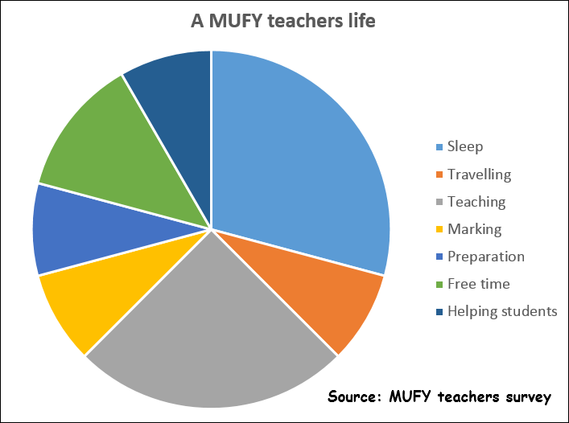

**Graph Analysis report**

1. **Introduction** (write one sentence describing the overall purpose of the graph).

|  |
| --- |
|  |
|  |
|  |

1. **Graph type and purpose** (write two sentences, one sentence identifying the type of graph, the 2nd sentence describing the genetic purpose of that type of graph).

|  |
| --- |
|  |
|  |
|  |

|  |
| --- |
|  |
|  |
|  |

1. **Data included** (write one sentence for each data item in the graph).

|  |
| --- |
|  |
|  |
|  |

1. **Main finding/trend** (write one sentence describing the main finding or trend in the graph).

|  |
| --- |
|  |
|  |
|  |

1. **Other findings** (select two or three other things that stand out in the graph – write one sentence for each area.)

|  |
| --- |
|  |
|  |
|  |

|  |
| --- |
|  |
|  |
|  |

|  |
| --- |
|  |
|  |
|  |

1. **Source of the data** (write one sentence identifying where the data came from).

|  |
| --- |
|  |
|  |
|  |

1. **Conclusion** (write one sentence, restating the main findings (in different words than above).

|  |
| --- |
|  |
|  |
|  |